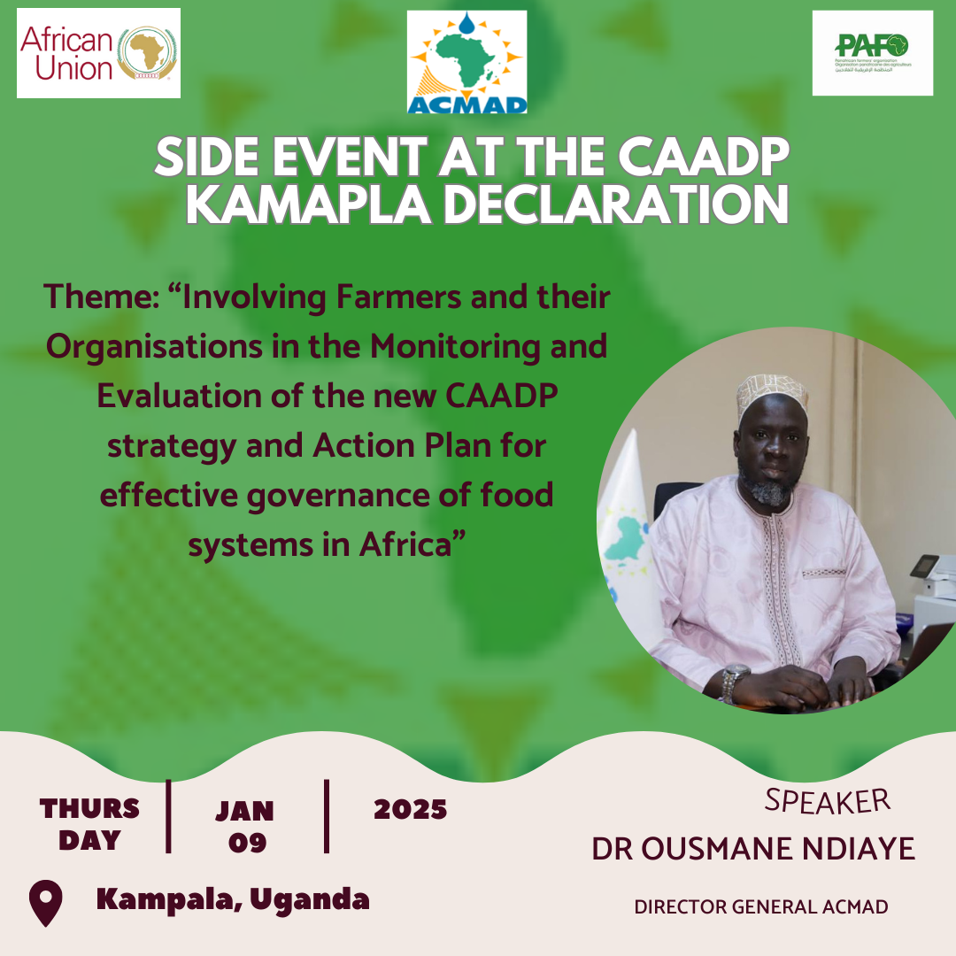

1. **Background**

**ACMAD joins forces with Pafo and other stakeholders at the AU Comprehensive Africa Agriculture Development Programme (CAADP) Summit to strengthen African Famers resilience**

In 2003, the African Union Heads of State and Government adopted the CAADP as the framework of action for agricultural transformation across Africa.

Adopted in 2003 by the AU heads of state and government, the CAADP is a framework of action for agricultural transformation across Africa. It is one of the major strategies towards realization of the African Union’s Agenda 2063 – ***The Africa We Want***. The CAADP aimed to envisage modern agriculture for increased productivity and production across the continent.

The CAADP is implemented through ten-year successive Strategies and Action Plans, with the first one being adopted in Maputo (Mozambique) in 2003 and the second in Malabo (Equatorial Guinea) in 2014 for the period 2015 – 2025. The third will be adopted during the forthcoming Summit in Kampala, Uganda.

The Extraordinary Summit will be attended by all the African Union Member States at Head of State and Government level or their delegates, participants including agricultural practitioners, researchers, development partners, and the media, the Summit will run under the theme of the CAADP Strategy and Action Plan 2026 – 2035 and the Assembly is: “***Sustainable and Resilient Agrifood Systems for a Healthy and Prosperous Africa***.”

The structure of the Extra-Ordinary Summit will be:

➢ 9th January 2025: Meeting of Ministers responsible for Agriculture;

➢ 10th January 2025: Meeting of Ministers of Foreign Affairs with Ministers in charge of Agriculture;

➢ 11th January 2025: Extra-Ordinary Summit of Heads of State and Government.

As part of the Summit, the African Union Commission (AUC) and Pan-African Farmers’ Organization (PAFO) will organize side-event on “***Involving Farmers and their Organisations in the Monitoring and Evaluation of the new CAADP strategy and Action Plan for effective governance of food systems in Africa***”. That side event will be held on 09th, January 2025.

In framework of the implementation of ClimSA’s project, ACMAD undertook discussion with PAFO (Pan African Farmers Federation Organization), to establish a MoU, which was a recommendation of the previous ClimSA steering committee meeting. After the Side event, ACMAD-PAFO will have the signature ceremony of the MoU.

The signature of the MoU is in line with ACMAD's Strategic Objective 2.2, which is to ensure improving climate services to reduce climate change impacts and support sustainable development, it is also an important event in the implementation of the recommendation of CLIMSA Project Steering Committee.

1. **OBJECTIVE**

The aim of the ACMAD team's participation is to attend the panel during the second session of the side event and topic of discussion on “***Involving Farmers and their Organisations in the Monitoring and Evaluation of the new CAADP strategy and Action Plan for effective governance of food systems in Africa***”.

During the side event ACMAD team will share with stakeholders and partners ACMAD's products and services for Agriculture sector and in the field of Disaster Resilience in Africa and climate services through key achievement.

It’s will also be opportunity to proceed with signature ceremony of the MoU and improve the visibility of ACMAD through the organization of side event, participation in panels and interviews on various.

1. **OUTPUTS**

* The major Outputs of the mission will be the participation at side event;
* Participate at singing ceremony of the MoU between ACMAD and PAFO;
* Participation in drafting Kampala Declaration;
* Participation at extra Africa day and in other side events as pannelist;
* Meeting with The Minister of Water and Environment and AMCOMET Chairman.